- Which measuring device is most accurate?
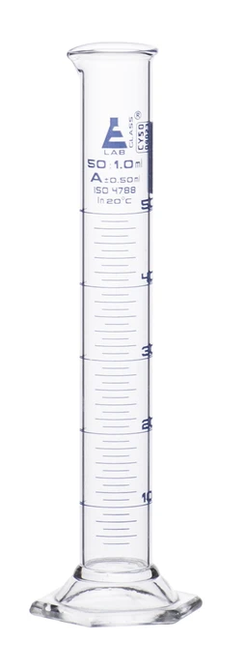
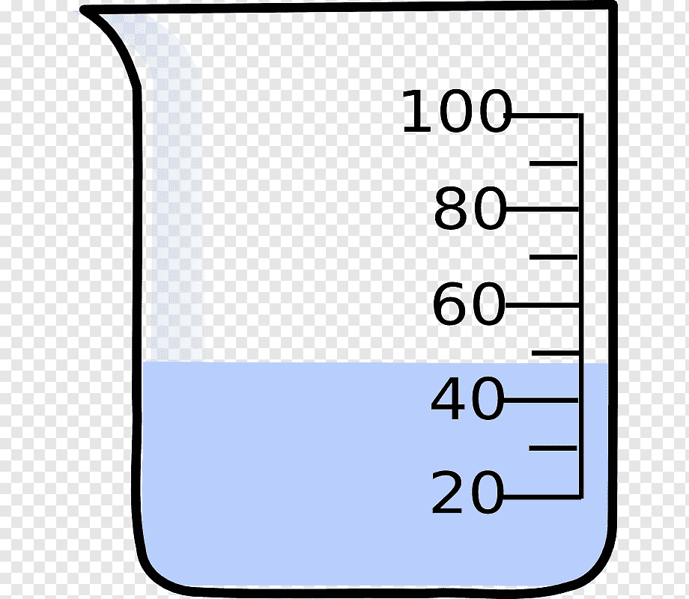
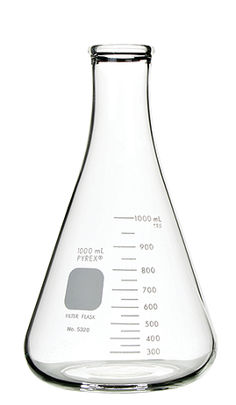

- Two students ran an experiment to determine the density of an unknown metal. Below are the results. Which student has the most precise data set?
Student A: 2.0 g/mL, 2.1 g/mL, 2.4 g/mL 2.0 g/mL, 2.8 g/mL
Student B: 1.7 g/mL, 2.2 g/mL, 2.5 g/mL, 2.6 g/mL, 2.7 g/mL

- Two students determine the boiling point of methyl alcohol. The results are shown below. The actual value is 64.7ºC. What is the percent error for each student? Which student was most accurate?

Student A | 67.0ºC
Student B | 61.1ºC

- The data set shown represents student scores on an exam. The standard deviation is 14.2.

Period | Scores | Standard deviation
5 | 88, 58, 87, 56, 92, 100, 78, 86 | 15.8
7 | 66, 72, 82, 50, 76, 96, 78, 95 | 15.1

What is the mean (average) for each period?

What is the precision for each period?

- The following data was collected from an experiment:

1.003 g, 1.005 g, 1.002 g, 1.000 g, 0.999 g, 1.008 g
- What is the mean or average?
- What is the mean or average? | /1
- The actual mass of the object is known to be 1.006 g. What is the percent error associated with this data set?

 | /1

- Two groups of students collected the following data:

Group A: 1.003 g, 1.005 g, 1.002 g, 1.000 g, 0.999 g, 1.008 g
Group B: 1.008 g, 1.015 g, 1.002 g, 1.000 g, 0.999 g, 1.010 g

The actual mass of the object is known to be 1.006 g
- Which data set is most precise? How do you know?

/2
- Which data set is most accurate? How do you know?

/2

- The exam scores for a chemistry are shown below. Use Google Sheets to answer the following,
- What is the average for each class?
- What is the standard deviation for each class?
- What is the precision for each class
Period 5 | Period 7
95 | 88
87 | 89
66 | 90
100 | 77
78 | 95
98 | 80
77 | 79
85 | 78
78 | 90
82 | 88
88 | 82
99 | 96
90 | 78
68 | 77
78 | 90
90 | 98
88 | 90
67 | 100
88 | 98
65 | 88

